West Genesee Training/Racing Trails – Camillus Middle School

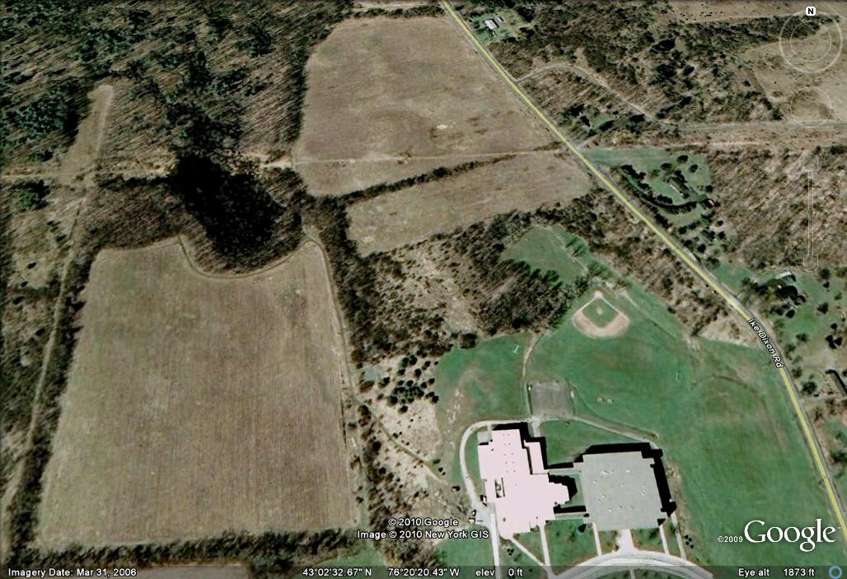

Existing Trails:

New 2010 Trails:

